GitHub/ Hackathons-FTW/ handbook

Handbook
for Hackathons powered by dribdat
December 2020
AUDIENCE
Organizers
The person or team that is responsible for organizing a hackathon, Hackdays, make-a-thon, or similarly time-limited collaborative problem-solving experience. This Handbook will give you basic information to confidently plan and set up dribdat.cc as a key digital platform for your event. We hope that it also answers questions that your supporters and participants may have about it.
Champions
The input of “challenge owners” who actively contribute content, help with funding or other practical support, you are decisive to the success of a Hackathon. Champions are often also the Organizers, and usually can be relied on to be active Participants of an event. Sometimes known in the role of “Ideators” or “Experts”, things tend to work best in our experience when they are able to blend themselves in well with a team. Nevertheless, we are keeping them as a separate Audience for the purposes of this document.
Participants
You are what it is all about. People who take their time, contribute their skills and knowledge and enthusiasm to make something happen. Supporting and recognizing your work is the goal of this Handbook, and your experience is the reason we work hard on open source tools like dribdat.

OVERVIEW
This document is structured in the form of descriptions of the standard processes that take place in a dribdat-powered event. For each process, you can find an explanation of the goals, procedures, and common issues, accompanied where necessary by screenshots from the tools. If you are new to Hackathons or dribdat, you can find background information in the section Additional Information near the end. This is a living document which you are welcome to contribute to. Currently the following processes are covered:

Announcing Challenges (Organizers, Champions)
Defining a profile role (all Participants)
Starting a challenge team (Organizers)
Joining a challenge team (all Participants)
Documenting a challenge project (all Participants)
Providing feedback (all Participants)
Additional Information about Hackathons and Dribdat
Further references

Announcing Challenges (Organizers, Champions)
As an event takes shape, the organizers and supporters come into contact to discuss the various ideas which will be presented at a Hackathon. Setting up a fresh instance of dribdat with a brief announcement of your event, its general goals and rough timeline, is a great way to get the process started. Once you have installed dribdat and created your first Hackathon, the prominent Announce challenge button leads to a form which can be used to document each proposal.
Steps
- Log into your dribdat instance with an administrator account.
- Create your first event on the home page, or use the Admin backend
- Optionally edit the “Getting started” content to include pertinent information
- Share the link to the new event page with potential Champions of the event
- Check in on their progress, and support them to collect details, slides, data, etc.
Goals
You should have in the end a nice and presentable event page with a variety of challenges to browse through. For an optimal team size of 4 people (physical) and 8 people (virtual), you can now work out your participation goals and start spreading the word about your upcoming event.
Risks
For larger events, multiple teams may often be encouraged to work on the same type of challenge. It may become cumbersome to navigate a single event when both challenge descriptions and projects are listed together. In this case, we suggest distributing them by topic using Categories in the Admin panel. This way projects can easily reference their respective challenge in a drop-down list.
The user interface of dribdat may be too constraining for the way you want to present your event’s challenges, and in this case you are welcome to publish challenges externally. Here again, Categories can be used to easily link external content to the solutions on the platform.

Defining a profile role (all Participants)
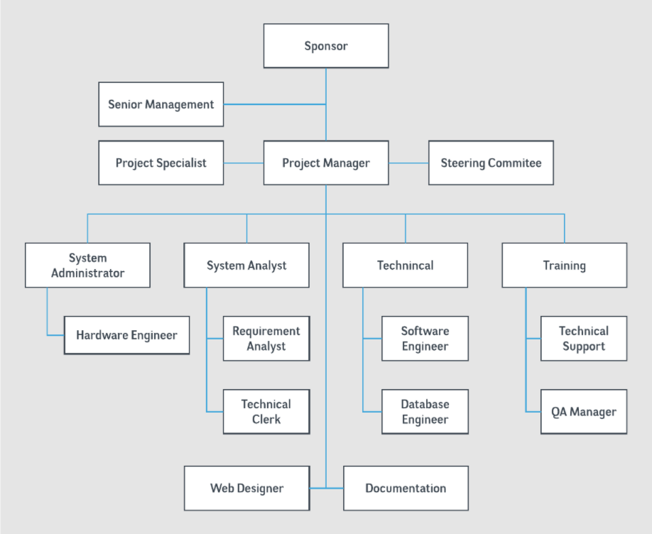
At a Hackathon, we try to do away with the typical hierarchy of the workplace. You know .... this kind of thing 👉
Nevertheless, we have important responsibilities to each other. For Participants, our main duty is to engage with and support fellow team-members, one of whom is probably a champion of the Challenge. It is important to know who is an Organizer, if you need to get assistance or report a problem. For this reason, it is possible to define and assign Roles.
Steps
- Creating your Profile. In order to create your Profile, at https://bd.hack4socialgood.ch/ using the email you registered with, go to the menu and click on . Then click the box .
- First pick your role, one you can fill on a team: practical designer, developer/coder, ideator, researcher/data analyst, hack staff. Others will see the icon of your role, and this will make it easier to find team members as needed.
- Scroll down to fill in all the blanks and add a short user name that won’t hide your role icon later (preferably under 10 characters).
- Don't forget to scroll to the bottom and hit 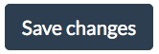when finished!
- Adding your profile picture. If you want to display your profile picture on dribdat, you can create a gravatar (globally recognized avatar that shows across multiple platforms) by going to https://en.gravatar.com. You will need to make an account with WordPress using your registration email and then add your profile picture to that. If you already have a WordPress account for that email, dribdat will use that image.
- Seeing who is working on which challenge. In order to see the other participants, FIRST go to the menu and CLICK ON . Scroll to the VERY BOTTOM of the page and then click on (to the right above the clock).
- These are participants who have already joined projects. Clicking on a participant’s name brick will lead you to their full profile, including the challenges they are working on.
Goals
At a hackathon, it is important to be able to recognize in a short time how we can help each other solve a challenge. Profiles are shorthand for this process.
Risks
The risk is that when we pre-assign roles, we fail to see the potential lurking in the less obvious and more outlandish possibilities. Keep both these things in mind when defining yourself and others.

Starting a challenge team (Organizers)
The challenges for this hackathon have already been created and the teams started. You can read about exploring and joining below.

Joining a challenge team (all Participants)
Steps
- Exploring the challenges. In order to explore the challenges, at https://bd.hack4socialgood.ch/ using the email you registered with, go to the menu and click on . These are challenges you can join for this hackathon. You can click on the challenge tiles to read about them.
- The Contact button for challenges looks like this 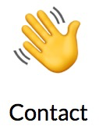 and is located at the bottom of each dribdat challenge page. It links to the channel on Microsoft (MS) Teams in which the challenge team can communicate with each other and exchange information and ideas. You can get this link in Microsoft Teams by right-clicking on the name of your channel and choosing the bottom option "Get link to channel".
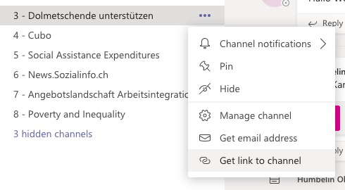
- The Source button for challenges looks like this 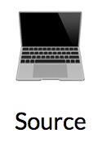 and is located at the bottom of each Dribdat challenge page. It links to your repository for code and data on github or elsewhere.
- In order to join a challenge, click on the challenge tile  you are interested in. On the page describing the challenge, look in the upper right corner and click on 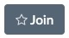. After joining, you can also then access that challenge and its details from your profile page. The challenge will now appear below in your profile, and your profile brick will appear on the dribdat participants page.
- If you wish to leave a challenge, you just click on the grey star in the bar .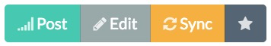

Goals
The goal is having a flexible process to find and join a challenge team which aligns with your interest and skills.
Risks
A risk is not distributing participant capabilities where they are most needed or can be best deployed. Another risk is that people choose to do the things they are used to doing instead of trying something slightly different. People tend to be less creative when they are doing what they are used to doing.

Documenting a challenge project (all Participants)

Steps
- Filling in a challenge project page. In order to fill in or update your challenge page, at https://bd.hack4socialgood.ch/ using the email you registered with, go to the menu and click on . Alternately, you can quickly access the challenge you have joined from your profile.
- Click on the grey Edit button of the bar . Scroll down and fill out the blanks with project information. In "Contact" you can provide the link to your challenge's chat channel. In "Source" you can provide the link to your repository of code and data in github.
- Don't forget to hit at the very bottom of the page!
- All participants should regularly report their progress in a challenge so that others know what work is being done. Click on the green Post button of the bar. Scroll down and document your progress stage and what you are working on now.
- Don't forget to hit at the very bottom of the page!

Goals
It is important to have and update a central page with links to all the resources and information which the whole team can access quickly. It’s also important for coordination and for motivation to let others know concretely how the challenge project is progressing by posting often.
Risks
The risk is of becoming more absorbed with a show of progress than with the nuts and bolts of tracking and organizing what you are accomplishing.

Additional Information about Hackathons and Dribdat
The word hackathon is a combination of the words “hacking” and “marathon”. A Hackathon is an event which includes creative problem solving, often involving technology, within a short-term time frame centered around challenges on a specific topic or from a specific community done by fluid teams of people bringing different skills and perspectives to the issue. Hackathons are held by large multinationals and small non-profit groups alike. Hackathon collaborations often result in useful apps or other tools that help solve everyday problems as well as more esoteric problems. You can learn more at https://hackathon.guide.
Dribdat is a home platform used for the collaboration and data generated during a hackathon. The interactions and information are coordinated and stored through dribdat, which stands for "driven by data". The thumbs up in the logo represents how data can be used as a positive driving factor in addressing challenges. On the website the  in the upper left is the home button. The creators of Dribdat (https://github.com/hackathons-ftw/dribdat) made the software open-source, which means it is free for anyone to use it, and anyone can make a modified version to use in a different way. It's a flexible and creative tool for finding flexible and creative solutions. It depends on contributions https://opencollective.com/dribdat).
The Hack4SocialGood is an example of a hackathon on dribdat https://bd.hack4socialgood.ch. The buttons on dribdat lead to the external page about the event which is on the website of the host, the Berner Fachhochschule. The tab leads to an external page hosting our community forum which supports open data.

Further references
If you have gotten this far and the Handbook still has not provided you with a tip, please contact the maintainers through our Mattermost chat server or via dribdat@datalets.ch

Addendum 1: dribdat and Microsoft Teams
Communication between participants can occur on Microsoft (MS) Teams.
The Bernerfachhochschule MS Team for the event is called "Hack4SocialGood 2020". Communication with everyone occurs in the channel "General". Communication between the members of a challenge team occurs on a channel named after their challenge on Microsoft (MS) Teams (Hack4Social Good 2020 Team of the Bernerfachhochschule) in which the challenge team can communicate with each other and exchange information and ideas.
MS Teams.
Everyone must be on the same platforms to ensure supple communication at the hackathon. If you don't have it, download and install the free version of MS Teams at https://www.microsoft.com/de-ch/microsoft-365/microsoft-teams/download-app. For this you will need a Microsoft account, which you can sign up for free if you don't have one yet. Next follow the group invitation you received from the email "Microsoft Teams noreply@email.teams.microsoft.com". You are in when you see the team «Hack4SocialGood 2020» and its list of challenge channels. Here are some MS Teams tips: https://support.microsoft.com/en-us/office/five-things-to-do-first-with-your-teams-free-org-2197d755-8af0-44f0-9b65-563c1eea51dc
Hackathon-wide meetings.
In order to see the online schedule with links for meetings, into the menu area using the email you registered with, go to the menu and click . Follow green Directlinks to access the video calls on Microsoft (MS) Teams.
Calling channel or smaller meetings.
Here are instructions for starting your own meetings in Teams, for instance for your channel.
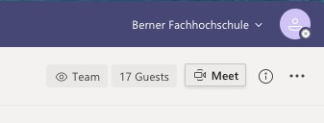
To start a meeting, hit the "(camera) Meet" button in the upper right corner.
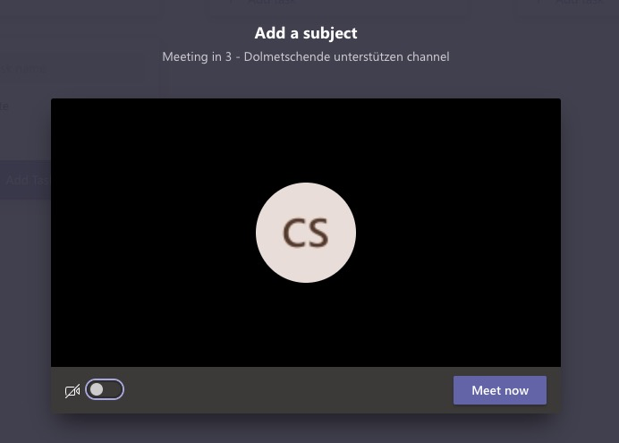
This generates a screen where you can also choose to start with your camera off. After you hit "Meet now" to start a call, you can choose other participants on the right hand side of the screen.

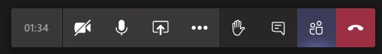
Here are some of the meeting icons, their locations and their meanings. Once you are in the meeting, there is a bar where you can
- see how much time has passed
- turn on and off your camera
- turn on and off your microphone
- share your whole screen or only one particular window or a whiteboard
- click three dots which give added options, including live captions
- raise your hand
- open the chat
- hide or show participants
- and hang up.
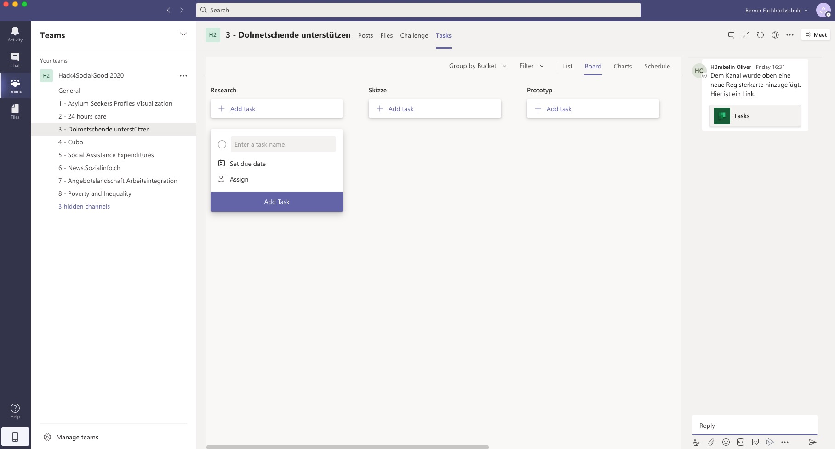
Challenge channels.
The channels appear on the left side of the screen under the Team name "Hack4Social Good 2020".

Communication between the members of a challenge team occurs on the channel named after their challenge. Members can start video/audio meetings with any number of people, add and jointly edit files, share and schedule tasks and chat in groups or individually.
The Contact button on dribdat looks like this and is located at the bottom of each Dribdat challenge page. It links to the channel on Microsoft (MS) Teams in which the challenge team can communicate with each other and exchange information and ideas. You can get this link by right-clicking on the name of your channel in Microsoft Teams and choosing the bottom option "Get link to channel".
The Source button on dribdat looks like this and is located at the bottom of each Dribdat challenge page. It links to your repository for code and data on github or elsewhere. If you do more hackathons, it is useful to become familiar with github.
Avoiding bloopers in MS Teams
Here are some tips on what to watch out for when you are tired and in a hurry on MS Teams: https://storyals.com/blog/5-mistakes-using-microsoft-teams

